**NEON stations - label data (target station)**

[**https://data.neonscience.org/data-products/DP1.00094.001**](https://data.neonscience.org/data-products/DP1.00094.001)

**Soil water content and water salinity**

**Description**

* Soil volumetric water content and an index of salinity *(concentrations of salts in soils)* at various depths below the soil surface from 6 cm down to 200 cm at non-permafrost sites **(terrestrial sites)**
* Data are collected from the five Instrumented soil plots per site and presented as 1-minute and 30-minute averages

**Abstract**

* Importance of Soil Moisture
* Data collected in any given month are published during the second full week of the following month
* After accounting for the flagging, the resulting soil water content data availability is currently at 30-50% (below its target availability)
* Consistent Calibration Coefficients can be applied over the entire time series can be found in reprocessSensorData.R
* [**https://doi.org/10.6084/m9.figshare.14599968.v1**](https://doi.org/10.6084/m9.figshare.14599968.v1) (reprocessSensorData)

**Documentation**

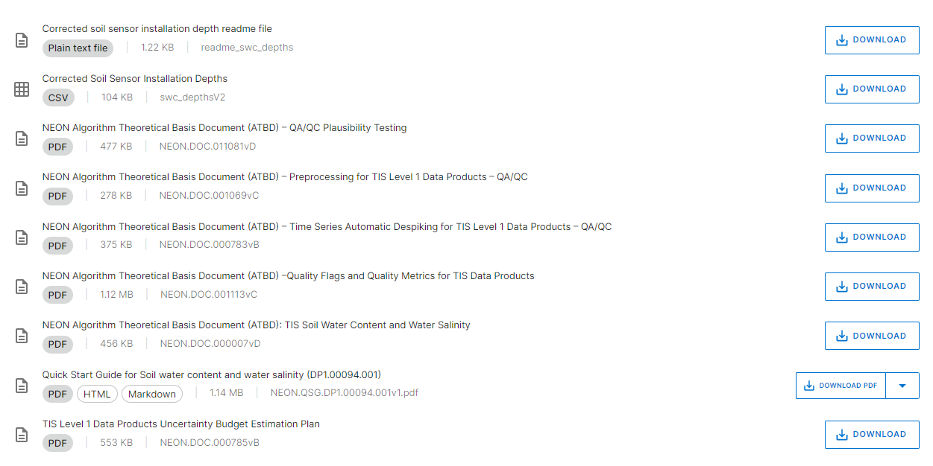

**Issue Log**

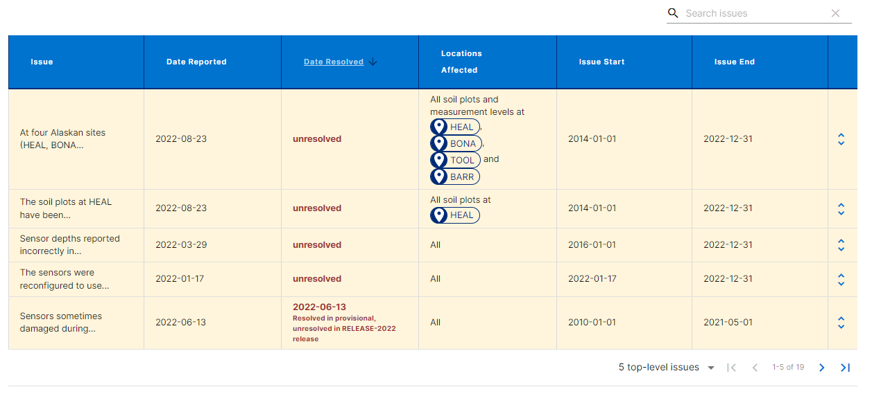

**Availability and Download**

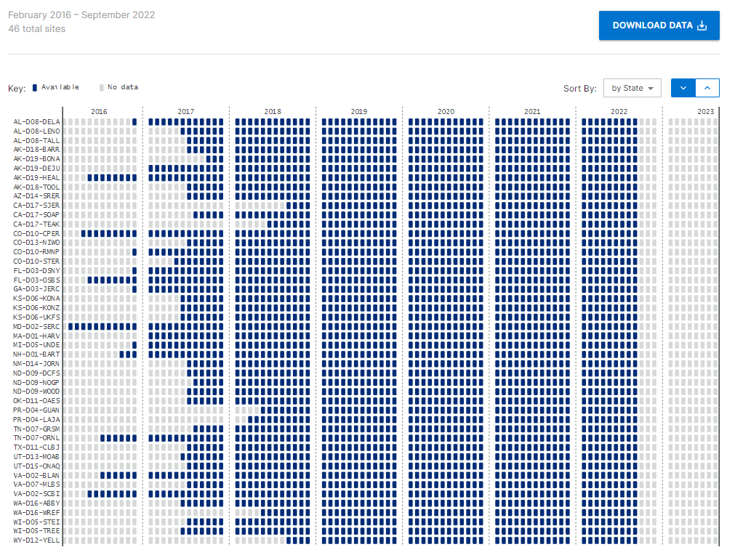

**Visualizations**

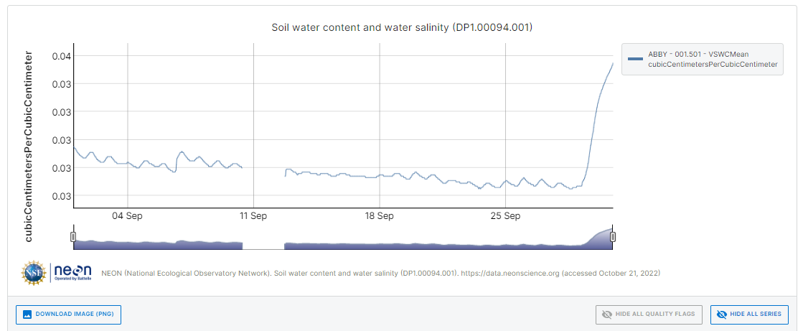

The National Science Foundation's National Ecological Observatory Network (NEON) is a continental-scale observation facility operated by Battelle and designed to collect long-term open access ecological data to better understand how U.S. ecosystems are changing.

NEON monitors ecosystems across the United States. Freshwater ecosystems include streams, rivers, and lakes while terrestrial ecosystems span from deserts to tropical forests.

**Data and Samples**

NEON takes millions of measurements and collects thousands of samples every year. This is the portal to access them.

NEON delivers hundreds of data products including organismal counts and measurements, water quality, energy fluxes, and remotely sensed vegetation indices.

**Explore and Download Data Products**

All of NEON's data products are free and open ([**https://data.neonscience.org/data-products/explore**](https://data.neonscience.org/data-products/explore)**)**

**Prototype Data**

Find datasets collected during the testing of new products, especially during the construction of NEON ([**https://data.neonscience.org/prototype-datasets**](https://data.neonscience.org/prototype-datasets))

**API and GraphQL**

Work more efficiently - query and download NEON data programmatically or from the command line ([**https://data.neonscience.org/data-api/**](https://data.neonscience.org/data-api/))

